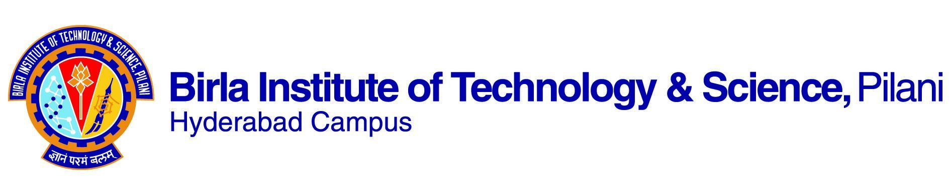

**First Semester 2023-2024**

Course Handout (Part II)

Date: 11-08-2023

In addition to Part I (General Handout for all courses appended to the Time Table), this portion gives further specific details regarding the course.

Course No.: **CHE F312**

Course Title: **Chemical Engineering Laboratory - I**

Instructor-in-charge: Dr. Srikanta Dinda

Instructors: Dr. Afkham Mir

# Scope

The objective of this lab course is to expose the students to the application of fundamental concepts learned in their Core Discipline Courses like Heat Transfer, Fluid Mechanics, Mass Transfer, and Selected Chemical Engineering Operations.

1. **Learning Outcomes**

* Handling various equipment and instruments
* Conducting experiments, troubleshooting, collecting precise data
* Data analysis and interpretation
* Understanding the application of Chemical Engineering concepts in industrial applications

1. **Text Books**

* Unit Operations of Chemical Engineering by McCabe and Smith.
* Introduction to Fluid Mechanics by Fox and McDonalds.
* Mass Transfer by Treybal.
* Relevant handouts and experiment manuals and instructions will be provided.

1. **List of Experiments:**

|  |  |  |
| --- | --- | --- |
| **S.N.** | Lab | **Experiment Objective** |
|  | TP | To determine Reynold’s number for laminar, transition, and turbulent fluid flow. |
|  | TP | To experimentally verify Bernoulli’s theorem. |
|  | TP | To determine the coefficient of discharge for Venturi & Orifice Meter with Air |
|  | TP | To determine the coefficient of discharge for Venturi & Orifice meter and calculate the skin friction losses in three pipes with water |
|  | TP | Fixed & Fluidized Bed- To verify the Ergun equation and incipient fluidization |
|  | TP | To determine the thermal conductivity of a solid by a static method. |
|  | TP | To determine overall heat transfer co-efficient for a composite wall. |
|  | TP | To determine the thermal conductivity of a liquid. |
|  | TP | To study of radiation heat transfer by black body & Test plate. |
|  | TP | To determine the heat transfer coefficient of air in a natural convection specification and to compare it with the theoretically calculated value of the same. |
|  | TP | To determine the heat transfer of air in a forced convection specification and to compare with the theoretically calculated value of the same. |
|  | TP | To study the heat transfer phenomena in shell and tube heat exchangers. |
|  | TP | To study the heat transfer phenomena in plate-type heat exchangers. |
|  | TP | To study the mass transfer of fluids in a wetted wall column. |
|  | TP | To determine the diffusion coefficient of liquid in the gaseous phase |
|  | TP | Liquid-liquid extraction-mass transfer studies between extract and raffinate |
|  | TP | To study the process of drop-wise and film-wise condensation. |
|  | TP | Bubble Cap Distillation Column-Mass transfer studies |
|  | TP | Sieve Plate Column-Mass transfer studies |
|  | TP | Studies on Pool boiling phenomena |

1. **Evaluation Scheme**

|  |  |  |  |  |
| --- | --- | --- | --- | --- |
| **Component** | **Duration** | **Weightage (%)** | Date and Time | Nature of Component |
| Regular experiments/Reports & Viva  (Pre-MID term) | 180 min /slot | 30 | Continuous evaluation | Open book |
| Lab Skill Test-1 | 120 min | 10 | TBA | Closed book |
| Written test-1 | 30 min | 10 | TBA | Closed book |
| Regular experiments/Reports & Viva  (Post-MID term) | 180 min /slot | 30 | Continuous evaluation | Open book |
| Lab Skill Tests-2 | 120 min | 10 | TBA | Closed book |
| Written test-2 | 30 min | 10 | TBA | Closed book |

**Make-up policy**

Make-up for the regular lab or tests shall be granted only for genuine reasons and with prior permission from the IC.

**Academic Honesty and Integrity Policy: Academic honesty and integrity are to be maintained by all the students throughout the semester, and no type of academic dishonesty is acceptable.**

**Dr. Srikanta Dinda**

**Instructor-in-Charge, CHE F312**